MEDIA RELEASE
May 29, 2024
Contact:
Info: Will Burns, ACCE, wburns@acce.org
Media: Lisa Nielsen lisa@bendchamber.org
703-998-3571
541-382-3221

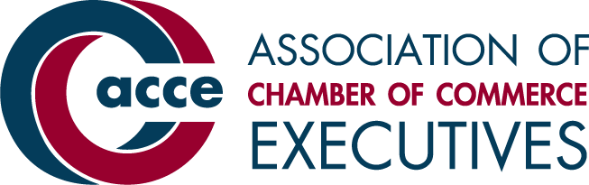

BEND CHAMBER NAMED finalist for PRESTIGIOUS CHAMBER OF the YEAR award

BEND, OR (May 29, 2024) — The Bend Chamber of Commerce has been named a finalist for the 2024 Chamber of the Year award, presented by the Association of Chamber of Commerce Executives (ACCE). ACCE is an association based in Alexandria, Va., with over 1,600 chambers of commerce and related business and economic development organizations as members, representing more than 9,000 professionals in the industry.

The award, sponsored by GrowthZone, is the most prestigious and competitive recognition presented annually by ACCE. It recognizes the leadership role chambers of commerce have in their communities. Those honored with the Chamber of the Year designation have demonstrated organizational strength and impacted key community priorities, such as education, transportation, economic prosperity and quality of life.
"This year's finalists represent the best in the chamber industry," said Sheree Anne Kelly, ACCE president & CEO. "They are community leaders and innovators, driving growth and regional prosperity. We congratulate them on this outstanding achievement."
Chamber of the Year winners will be announced on Wednesday, July 17, during the Awards Show at ACCE’s Annual Convention in Dallas, Texas.

“We are excited to be counted as a top chamber in the country,” said Katy Brooks, Bend Chamber CEO. “As advocates for Bend’s businesses and our local economy, we have worked hard to address impacts of rapid population growth, including housing costs, lack of childcare, and a cohesive, connected labor force.”

Chambers of commerce interested in competing for the award first must qualify by participating in a vigorous multi-stage process. Organizations entering the Chamber of the Year competition must meet minimum thresholds in at least three of five key performance areas in ACCE’s Annual Chamber Operations Survey, including net revenue and assets, membership account retention and membership dollar retention.

Qualifying chambers enter the competition with a written application addressing all organizational operation and programmatic work aspects. Applications are scored by peer chamber executives to determine finalists. Winners are selected from among finalists based on an interview before a panel of experienced chamber professionals.

To ensure the fairest competition, applicants are grouped into four categories based on annual revenue, membership, area population and other factors.

# # #

About the Bend Chamber of Commerce
The mission of the Bend Chamber is to create an environment where businesses, their employees and our community excel together through collaboration, advocacy, resources and leadership to meet Bend’s business challenges.

About the Association of Chamber of Commerce Executives
Association of Chamber of Commerce Executives (ACCE) is the professional society supporting the women and men who lead local, regional, statewide and international chambers of commerce and related business and economic development organizations. Our membership includes more than 1,600 business/civic organizations worldwide. We provide our members with information resources, thought leadership, education programs, original research, benchmarking, retirement security, and access to a network of peers.

About the award sponsor GrowthZone
GrowthZone is association software that helps organizations grow and retain membership, engage and inform members and prospects, and streamline tedious tasks. It unlocks the full potential of member-based organizations and seamlessly integrates with core processes, providing the foundation for an organization’s strategy. Learn more about GrowthZone at https://www.growthzone.com/.

